## Interleaving

Interleaving is the reordering of data that is to be transmitted so that consecutive bytes of data are distributed over a larger sequence of data to reduce the effect of burst errors. The use of interleaving greatly increases the ability of error protection codes to correct for burst errors. Many of the error protection coding processes can correct for small numbers of errors, but cannot correct for errors that occur in groups.

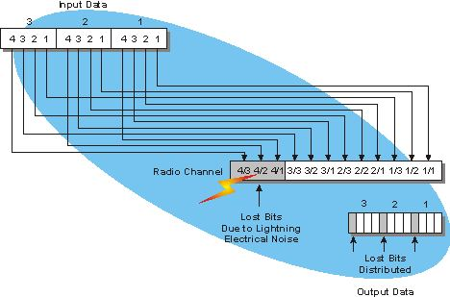

Figure 1: Interleaving Operation.

This diagram shows that a block of data information may be distributed over multiple time slots or frames in a carrier line to distribute the effect of burst errors on the information signal. In this example, a block of digital audio is being transmitted through a radio channel. The digital audio is divided into blocks of 4 bits and the bits for each block are distributed (interleaved) over a communication channel. During the transmission, a lightning bolt creates a burst of electrical noise that disrupts 3 bits of data transmission. Because these bits are interleaved, the received data has burst errors that are distributed. This allows the audio to be continuously heard with a marginal amount of distortion instead of completely losing the audio during the burst errors.[1]

The inputs to the interleaver are:

1. Data Bits
2. RI (Rank Information) Control Bits
3. ACK (Acknowledgement) Control Bits

The interleaving operation is done as follows:

**Step 1:** an $(R_{mux} × C_{mux})$ matrix is constructed (shown in Figure 2) where:

$C_{mux}= N_{symb}^{PUSCH}$ (Number of SC-FDMA symbols carrying PUSCH in a subframe = 12), and

$R_{mux}= {(H}^{''}∙Q_{m}) / C_{mux}$ ( $H^{''}$ is the total number of data and RI bits. $Q_{m}$ is the number of bits per symbol)

Let’s denote the inputs to the interleaver by $\underline{g_{0}},\underline{g_{1}},\underline{g_{2}},…,\underline{g_{H^{'}-1}}$, $\underline{q_{0}^{RI}},\underline{q_{1}^{RI}},\underline{q_{2}^{RI}}, …, \underline{q_{Q_{RI}^{'}-1}^{RI}},$ and $\underline{q_{0}^{ACK}},\underline{q_{1}^{ACK}},\underline{q_{2}^{ACK}}, …, \underline{q_{Q_{ACK}^{'}-1}^{ACK}}$ respectively.

We also define $R_{mux}^{'}=R_{mux}/Q_{m}$ (it represents the number of rows for the symbols)

**Step 2:** if rank information is transmitted in this subframe, the vector sequence $\underline{q_{0}^{RI}},\underline{q_{1}^{RI}},\underline{q_{2}^{RI}}, …, \underline{q_{Q_{RI}^{'}-1}^{RI}}$ is written onto the columns indicated by Table 1, and by sets of $Q_{m}$ rows starting from the last row and moving upwards according to the following pseudocode:

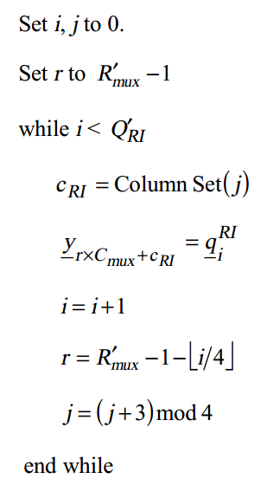

Where ColumnSet is given in Table 1 and indexed left to right from 0 to 3.

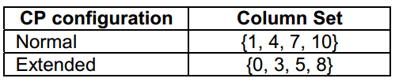

Table 1: Column set for Insertion of rank information.

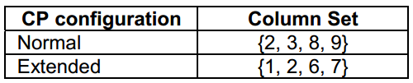

Table 2: Column set for Insertion of HARQ-ACK information.

After this step is done, RI bits will be placed in the cells (elements) as shown in Figure 2. These locations are chosen because **r** starts from the last row and **j** is varying as follows: $0,3,2,1,0,3,…$ which results in column numbers $1,10,7,4,1,10,…$

**Step 3:** write the input vector sequence, for $k=0,1,…,(H^{'}-1)$, into the matrix by sets of $Q_{m}$ rows starting with the vector $\underline{y_{0}}$ in column 0 and row 0 to ${(Q}_{m}-1)$ and skipping the matrix entries that are already occupied:

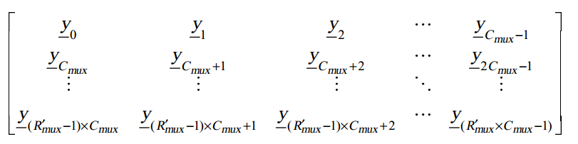

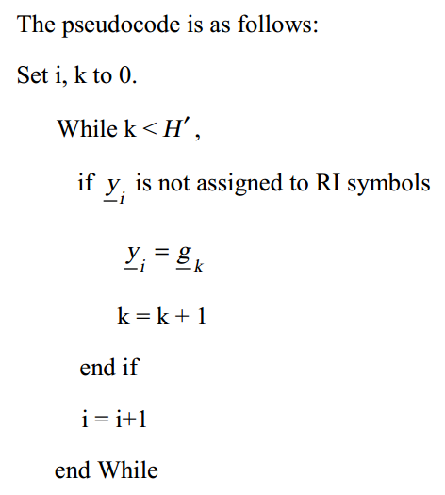

**Step 4:** if HARQ-ACK information is transmitted in this subframe, the vector sequence $\underline{q_{0}^{ACK}},\underline{q_{1}^{ACK}},\underline{q_{2}^{ACK}}, …, \underline{q_{Q_{ACK}^{'}-1}^{ACK}}$ is written onto the columns indicated by Table 2, and by sets of $Q_{m}$ rows starting from the last row and moving upwards according to the following pseudocode. Note that this operation overwrites some of the channel interleaver entries obtained in **Step 3**.

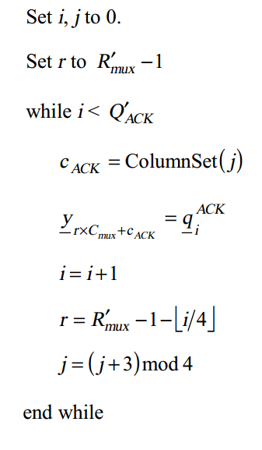

Where ColumnSet is given in Table 2 and indexed left to right from 0 to 3.

**Step 5:** the output of the block interleaver is the bit sequence read out column by column from the constructed matrix.

|  |  |  |  |  |  |  |  |  |  |  |  |  |  |  |  |
| --- | --- | --- | --- | --- | --- | --- | --- | --- | --- | --- | --- | --- | --- | --- | --- |
|  | **0** | **1** | **2** | **3** | **4** | **5** | **6** | **7** | **8** | **9** | **10** | **11** |  |  |  |
| **0** |  |  |  |  |  |  |  |  |  |  |  |  |  |  |  |
| **1** |  |  |  |  |  |  |  |  |  |  |  |  |  |  |  |
| **2** |  |  |  |  |  |  |  |  |  |  |  |  |  |  | **RI Bits** |
| **3** |  |  |  |  |  |  |  |  |  |  |  |  |  |  | **ACK Bits** |
|  |  |  |  |  |  |  |  |  |  |  |  |  |  |  |  |
| **.** |  |  |  |  |  |  |  |  |  |  |  |  |  | $$S_{i}$$ | $$b_{0}$$ |
| **.** |  |  |  |  |  |  |  |  |  |  |  |  |  | $$b_{1}$$ |
| **.** |  |  |  |  |  |  |  |  |  |  |  |  |  | **…** |
|  |  |  |  |  |  |  |  |  |  |  |  |  |  | $$b_{Q_{m}-1}$$ |
| $$R_{mux}^{'}-1$$ |  | $$S_{1}$$ | $$S_{1}$$ | $$S_{4}$$ | $$S_{4}$$ |  |  | $$S_{3}$$ | $$S_{3}$$ | $$S_{2}$$ | $$S_{2}$$ |  |  |  |  |

Figure 2: The $(R_{mux}^{'} × C_{mux})$ Matrix constructed in step 1.

The yellow columns show the allowed locations for the RI Bits, while the blue locations are for the ACK Bits. This is only valid for the case of Normal CP.

1. http://www.wirelessdictionary.com/Wireless-Dictionary-Interleaving-Definition.html